UEE410 Submitted by:

Abhiveer Pathania

102354005

3D12

Assignment 2

// Question 1: Write a program to check whether a given number is present in an array or not (Linear search).

#include <stdio.h>

int main() {

    int arr[] = {10, 20, 30, 40, 50, 60, 70, 80, 90, 100};

    int size = sizeof(arr) / sizeof(arr[0]);

    int search_num, found = 0, i;

    printf("Enter the number to search for: ");

    scanf("%d", &search_num);

    for (i = 0; i < size; i++) {

        if (arr[i] == search_num) {

            found = 1;

            break;

        }

    }

    if (found) {

        printf("%d is present in the array at index %d.\n", search_num, i);

    } else {

        printf("%d is not present in the array.\n", search_num);

    }

    return 0;

}



// Question 2: Write a program to get second maximum and second minimum elements in an array.

#include <stdio.h>

#include <limits.h>

int main() {

    int arr[] = {12, 45, 1, 9, 87, 33, 22, 98};

    int n = sizeof(arr) / sizeof(arr[0]);

    int max1, max2, min1, min2;

    int i;

    if (n < 2) {

        printf("Array should have at least two elements.\n");

        return 1;

    }

    // Initialize first and second max/min

    if (arr[0] > arr[1]) {

        max1 = arr[0];

        max2 = arr[1];

        min1 = arr[1];

        min2 = arr[0];

    } else {

        max1 = arr[1];

        max2 = arr[0];

        min1 = arr[0];

        min2 = arr[1];

    }

    for (i = 2; i < n; i++) {

        // Check for max

        if (arr[i] > max1) {

            max2 = max1;

            max1 = arr[i];

        } else if (arr[i] > max2 && arr[i] < max1) {

            max2 = arr[i];

        }

        // Check for min

        if (arr[i] < min1) {

            min2 = min1;

            min1 = arr[i];

        } else if (arr[i] < min2 && arr[i] > min1) {

            min2 = arr[i];

        }

    }

    printf("Second maximum element: %d\n", max2);

    printf("Second minimum element: %d\n", min2);

    return 0;

}



// Question 3: Write a program to perform insertion (any location), deletion (any location) and traversal in an array.

#include <stdio.h>

#define MAX_SIZE 100

// Function to traverse and print the array

void traverseArray(int arr[], int size) {

    printf("Array elements: ");

    for (int i = 0; i < size; i++) {

        printf("%d ", arr[i]);

    }

    printf("\n");

}

// Function to insert an element at a given position

int insertElement(int arr[], int size, int element, int position) {

    if (size >= MAX_SIZE) {

        printf("Array is full. Insertion failed.\n");

        return size;

    }

    if (position < 0 || position > size) {

        printf("Invalid position. Insertion failed.\n");

        return size;

    }

    for (int i = size; i > position; i--) {

        arr[i] = arr[i - 1];

    }

    arr[position] = element;

    return size + 1;

}

// Function to delete an element at a given position

int deleteElement(int arr[], int size, int position) {

    if (position < 0 || position >= size) {

        printf("Invalid position. Deletion failed.\n");

        return size;

    }

    for (int i = position; i < size - 1; i++) {

        arr[i] = arr[i + 1];

    }

    return size - 1;

}

int main() {

    int arr[MAX_SIZE] = {10, 20, 30, 40, 50};

    int size = 5;

    printf("Original ");

    traverseArray(arr, size);

    // Insertion

    int element_to_insert = 99, insert_pos = 2;

    printf("\nInserting %d at position %d...\n", element_to_insert, insert_pos);

    size = insertElement(arr, size, element_to_insert, insert_pos);

    traverseArray(arr, size);

    // Deletion

    int delete_pos = 3;

    printf("\nDeleting element at position %d...\n", delete_pos);

    size = deleteElement(arr, size, delete_pos);

    traverseArray(arr, size);

    return 0;

}

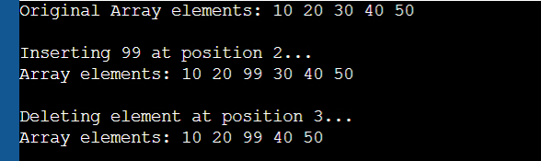

// Question 4: Write a menu driven program to perform addition, multiplication and subtraction of 2 arrays.

#include <stdio.h>

void displayArray(int arr[], int size) {

    for (int i = 0; i < size; i++) {

        printf("%d ", arr[i]);

    }

    printf("\n");

}

void addArrays(int arr1[], int arr2[], int result[], int size) {

    for (int i = 0; i < size; i++) {

        result[i] = arr1[i] + arr2[i];

    }

}

void subtractArrays(int arr1[], int arr2[], int result[], int size) {

    for (int i = 0; i < size; i++) {

        result[i] = arr1[i] - arr2[i];

    }

}

void multiplyArrays(int arr1[], int arr2[], int result[], int size) {

    for (int i = 0; i < size; i++) {

        result[i] = arr1[i] * arr2[i];

    }

}

int main() {

    int arr1[] = {1, 2, 3, 4, 5};

    int arr2[] = {5, 4, 3, 2, 1};

    int size = 5;

    int result[5];

    int choice;

    do {

        printf("\nMenu:\n");

        printf("1. Add arrays\n");

        printf("2. Subtract arrays\n");

        printf("3. Multiply arrays\n");

        printf("4. Exit\n");

        printf("Enter your choice: ");

        scanf("%d", &choice);

        switch (choice) {

            case 1:

                addArrays(arr1, arr2, result, size);

                printf("Result of Addition: ");

                displayArray(result, size);

                break;

            case 2:

                subtractArrays(arr1, arr2, result, size);

                printf("Result of Subtraction: ");

                displayArray(result, size);

                break;

            case 3:

                multiplyArrays(arr1, arr2, result, size);

                printf("Result of Multiplication: ");

                displayArray(result, size);

                break;

            case 4:

                printf("Exiting program.\n");

                break;

            default:

                printf("Invalid choice. Please try again.\n");

        }

    } while (choice != 4);

    return 0;

}

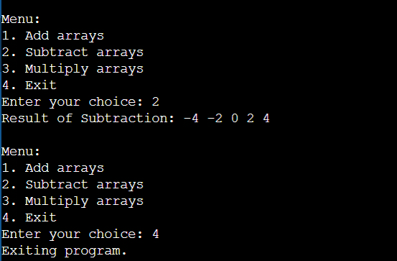

// Question 5: Write a program to perform sorting while merging (Merge two sorted arrays into one sorted array).

#include <stdio.h>

void mergeSortedArrays(int arr1[], int size1, int arr2[], int size2, int result[]) {

    int i = 0, j = 0, k = 0;

    // Merge the arrays

    while (i < size1 && j < size2) {

        if (arr1[i] < arr2[j]) {

            result[k++] = arr1[i++];

        } else {

            result[k++] = arr2[j++];

        }

    }

    // Copy remaining elements of arr1

    while (i < size1) {

        result[k++] = arr1[i++];

    }

    // Copy remaining elements of arr2

    while (j < size2) {

        result[k++] = arr2[j++];

    }

}

void printArray(int arr[], int size) {

    for (int i = 0; i < size; i++) {

        printf("%d ", arr[i]);

    }

    printf("\n");

}

int main() {

    int arr1[] = {1, 3, 5, 7, 9};

    int size1 = sizeof(arr1) / sizeof(arr1[0]);

    int arr2[] = {2, 4, 6, 8, 10};

    int size2 = sizeof(arr2) / sizeof(arr2[0]);

    int result_size = size1 + size2;

    int result[result_size];

    mergeSortedArrays(arr1, size1, arr2, size2, result);

    printf("Merged and sorted array: ");

    printArray(result, result_size);

    return 0;

}

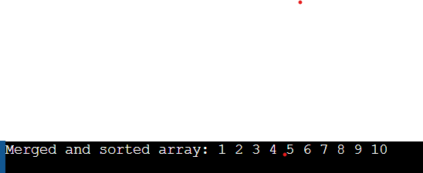

// Question 6: Write the above programs (1, 2, and 3) using functions and call by address only.

// Question 1 (Revisited): Linear Search with Call by Address

#include <stdio.h>

int linearSearch(int *arr, int size, int *search_num, int *found_index) {

    for (int i = 0; i < size; i++) {

        if (*(arr + i) == *search_num) {

            *found_index = i;

            return 1; // Found

        }

    }

    return 0; // Not found

}

int main() {

    int arr[] = {10, 20, 30, 40, 50};

    int size = 5;

    int search_num = 30;

    int found_index = -1;

    if (linearSearch(arr, size, &search_num, &found_index)) {

        printf("Element %d found at index %d.\n", search_num, found_index);

    } else {

        printf("Element %d not found.\n", search_num);

    }

    return 0;

}



// Question 2 (Revisited): Second Max/Min with Call by Address

#include <stdio.h>

void findSecondMaxMin(int *arr, int size, int *second_max, int *second_min) {

    int max1, max2, min1, min2;

    int i;

    if (size < 2) {

        printf("Array should have at least two elements.\n");

        return;

    }

    if (arr[0] > arr[1]) {

        max1 = arr[0];

        max2 = arr[1];

        min1 = arr[1];

        min2 = arr[0];

    } else {

        max1 = arr[1];

        max2 = arr[0];

        min1 = arr[0];

        min2 = arr[1];

    }

    for (i = 2; i < size; i++) {

        if (arr[i] > max1) {

            max2 = max1;

            max1 = arr[i];

        } else if (arr[i] > max2 && arr[i] < max1) {

            max2 = arr[i];

        }

        if (arr[i] < min1) {

            min2 = min1;

            min1 = arr[i];

        } else if (arr[i] < min2 && arr[i] > min1) {

            min2 = arr[i];

        }

    }

    *second_max = max2;

    *second_min = min2;

}

int main() {

    int arr[] = {12, 45, 1, 9, 87, 33, 22, 98};

    int size = sizeof(arr) / sizeof(arr[0]);

    int second_max, second_min;

    findSecondMaxMin(arr, size, &second_max, &second_min);

    printf("Second maximum element: %d\n", second_max);

    printf("Second minimum element: %d\n", second_min);

    return 0;

}



// Question 3 (Revisited): Array operations with Call by Address

#include <stdio.h>

void traverse(int *arr, int size) {

    printf("Array elements: ");

    for (int i = 0; i < size; i++) {

        printf("%d ", *(arr + i));

    }

    printf("\n");

}

int insert(int *arr, int *size, int element, int position) {

    if (position < 0 || position > *size) {

        printf("Invalid position for insertion.\n");

        return 0;

    }

    for (int i = *size; i > position; i--) {

        *(arr + i) = *(arr + i - 1);

    }

    *(arr + position) = element;

    (*size)++;

    return 1;

}

int delete(int *arr, int *size, int position) {

    if (position < 0 || position >= *size) {

        printf("Invalid position for deletion.\n");

        return 0;

    }

    for (int i = position; i < *size - 1; i++) {

        *(arr + i) = *(arr + i + 1);

    }

    (*size)--;

    return 1;

}

int main() {

    int arr[100] = {10, 20, 30, 40, 50};

    int size = 5;

    printf("Original ");

    traverse(arr, size);

    insert(arr, &size, 99, 2);

    printf("After insertion: ");

    traverse(arr, size);

    delete(arr, &size, 3);

    printf("After deletion: ");

    traverse(arr, size);

    return 0;

}

